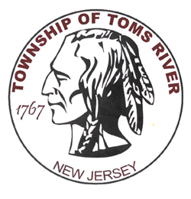
TOMS RIVER
POLICE DEPARTMENT
255 Oak Avenue P.O. Box 876
Toms River NJ 08754

Jillian Messina
Office of the Chief Media Relations Specialist
Mitchell A. Little 732-349-0150 Ext. 1878
Email: jmessina@trpolice.org
PRESS RELEASE

December 31, 2018

Suspicious Package

At approximately 1:40 PM on Monday, December 31st, Toms River Police responded to the Rite Aid located at 1726 Rt. 37 in reference to a suspicious package. Upon arrival, employees advised the responding officers that they opened up a mail package that was delivered to the store and located a newspaper inside. The employees stated that they believed that they may have been exposed to an unknown powder like substance that was either on the newspaper or inside the box. Preliminary inspection of the package by the New Jersey State Police HAZMAT Unit and the Berkeley Township HAZMAT Unit deemed the package to be safe. Two Rite Aid employees were transported to Community Medical Center out of an abundance of caution.

The media and the public are reminded that criminal charges are accusations only. Every criminal defendant is presumed innocent unless and until proven guilty in court.

