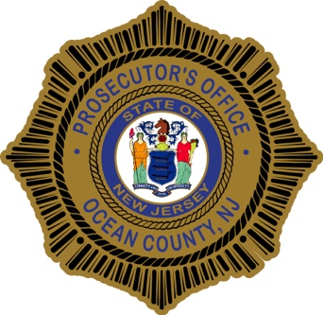
PRESS RELEASE

FOR IMMEDIATE RELEASE CONTACT: Al Della Fave
Ocean County Prosecutor’s Office
August 7, 2018 P.O. Box 2191
Toms River, NJ 08753
Phone: (732) 288-7616
Cellular: (732) 814-7347

ROUTE 70 POLICING PARTNERSHIP DETAIL ACCOUNTS FOR 317 MV STOPS
Ocean County Prosecutor Joseph D. Coronato today announced the results of his Safety/Enforcement Initiative to raise awareness and foster responsible driving behavior along the length of Route 70 in Ocean County and into a portion of Monmouth County.

The efforts of the partnership focused on seven (7) municipal jurisdictions traversing Highway Route 70 in Ocean and Monmouth County from Wall Township and Brielle Borough (Monmouth County) traversing Brick Township, Lakewood Township, Toms River Township, Manchester Township and Lakehurst Borough.in Lakewood Township. The initiative resulted from the numerous serious motor vehicle accidents that had occurred on this highway. Over 2016 there were 548 motor vehicle crashes on SH 70 including 10% of the fatal crashes within Ocean County. In 2017 the percentage of fatalities attributed to SH 70 rose to 19%.

- more -

From the July 20th start of the enforcement program, which included two days of saturation enforcement by the participating departments, the Route 70 detail produced a total of 212 summons issued with 317 vehicles stopped. There were two (2) arrests for Driving Under the Influence, two (2) wanted subjects arrested, and one (1) arrest for drug possession. The participating departments were happy to observe that the majority of motorists were choosing to drive responsibly. There were no fatalities or accidents involving serious injury during the period.

This multi-jurisdictional effort was supported by the Chiefs of Police and supervisors from the following jurisdictions:

Brick Police Department
Brielle Police Department
Lakehurst Police Department
Lakewood Police Department
Manchester Police Department
Toms River Police Department
Wall Township Police Department
Ocean County Prosecutor’s Office
NJ State Police Troop “C” – Tactical Patrol Unit
NJ State Police – D.U.I. Enforcement Patrol
Ocean County Road Department
Ocean County Engineering Department

The enforcement initiative sought to bring strict and aggressive traffic enforcement of the various moving and equipment violations that are contributory causes to crashes. These causes include, but are not limited to, Driving While Under the Influence, aggressive drivers, improper turning, failing to yield, failing to keep right, improper passing, inattentive driving, disregard of traffic signal, excessive speed, following too close, pedestrian violations and various commercial carrier violations such as overweight, equipment maintenance and brake pressure.

The participating agencies utilized Automated License Plate Readers to identify those operating illegally. Variable Message Signs were strategically placed reading "Traffic Enforcement Detail in Effect" - "Obey All Traffic Laws". Ocean County Prosecutor's Office personnel assigned to the detail utilized unmarked police vehicles to covertly observe and report violators.

The coordinated enforcement element has concluded, but policing agencies along Route 70 will continue to make traffic enforcement a priority. Now that the partnership logistics and plans have been worked out, the coordinated enforcement element can be quickly reinstituted in the event of increased reports of accidents or dangerous driving behaviors.

Follow the Office of the Ocean County Prosecutor online at Twitter and Facebook. The social media links provided are for reference only. The OCPO does not endorse any non-governmental websites, companies or applications.

For additional information visit our website at www.oceancountyprosecutor.org.

